¡Vamos a trabajar la atención!

**¡Me tranquilizo buscando las palabras!**

1. Concéntrate, siéntate en un lugar tranquilo y busca las emociones y sentimientos en esta sopa de letras. Coloréalas y tacha la que encontraste.

|  |  |  |  |  |  |  |  |  |  |  |  |  |  |
| --- | --- | --- | --- | --- | --- | --- | --- | --- | --- | --- | --- | --- | --- |
| **A** | **H** | **B** | | **U** | **A** | | **M** | **O** | | **R** | **X** | | **Z** |
| **F** | **C** | **S** | | **O** | **R** | | **P** | **R** | | **E** | **S** | | **A** |
| **A** | **O** | **A** | | **P** | **X** | | **S** | **Q** | | **R** | **F** | | **G** |
| **Z** | **N** | **L** | | **N** | **L** | | **K** | **LL** | | **S** | **A** | | **V** |
| **N** | **F** | **E** | | **A** | **S** | | **C** | **O** | | **O** | **Z** | | **Z** |
| **E** | **U** | **G** | | **N** | **Ñ** | | **A** | **N** | | **L** | **E** | | **M** |
| **U** | **S** | **R** | | **M** | **F** | | **D** | **N** | | **E** | **T** | | **I** |
| **G** | **I** | **I** | | **W** | **P** | | **A** | **I** | | **C** | **S** | | **E** |
| **R** | **O** | **A** | **U** | | **F** | **P** | | **D** | **H** | | **I** | **D** | |
| **E** | **N** | **K** | **M** | | **Q** | **T** | | **Y** | **O** | | **R** | **O** | |
| **V** | **A** | **M** | **L** | | **A** | **C** | | **S** | **C** | | **T** | **Y** | |



**Alegría. Amor. Cansancio. Asco.**

**Tristeza. Vergüenza. Confusión. Celos.**

**Enfado. Miedo. Sorpresa. Calma.**

1. Concéntrate, siéntate en un lugar tranquilo e identifica las 6 emociones representadas en las imágenes, para luego buscarlas y colorearlas en la sopa de letras. Cuando las encuentres escríbelas en las líneas de abajo.

|  |  |  |  |  |  |  |  |  |
| --- | --- | --- | --- | --- | --- | --- | --- | --- |
| **T** | **X** | **F** | **P** | **N** | **Q** | **L** | **K** | **A** |
| **R** | **A** | **A** | **R** | **V** | **O** | **B** | **J** | **S** |
| **I** | **W** | **Z** | **X** | **D** | **A** | **E** | **R** | **E** |
| **S** | **A** | **L** | **E** | **G** | **R** | **I** | **A** | **R** |
| **T** | **Y** | **I** | **A** | **G** | **U** | **A** | **S** | **P** |
| **E** | **M** | **M** | **L** | **Ñ** | **R** | **S** | **C** | **R** |
| **Z** | **O** | **P** | **L** | **A** | **N** | **P** | **O** | **O** |
| **A** | **I** | **R** | **I** | **R** | **A** | **O** | **G** | **S** |







1._______________ 4.______________

2._______________ 5.______________

3._______________ 6.______________

**¡Analizo mi energía y busco las diferencias!**

1. Observa detalladamente las siguientes imágenes y encierra en un círculo las diferencias que encuentres.

Encuentra las 3 diferencias.



Encuentra las 5 diferencias.

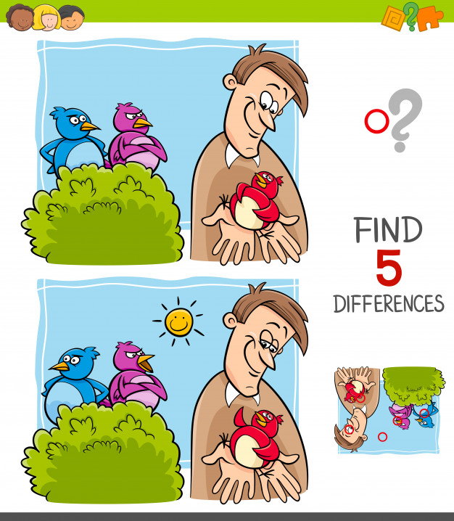

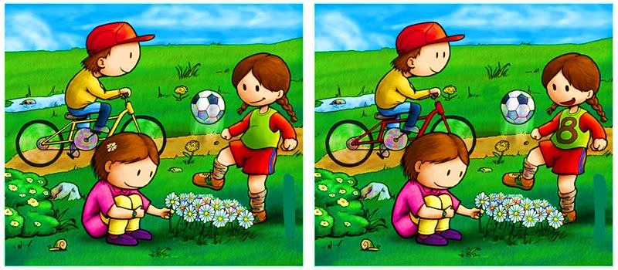

Encuentra las 7 diferencias.



Encuentra las 10 diferencias.

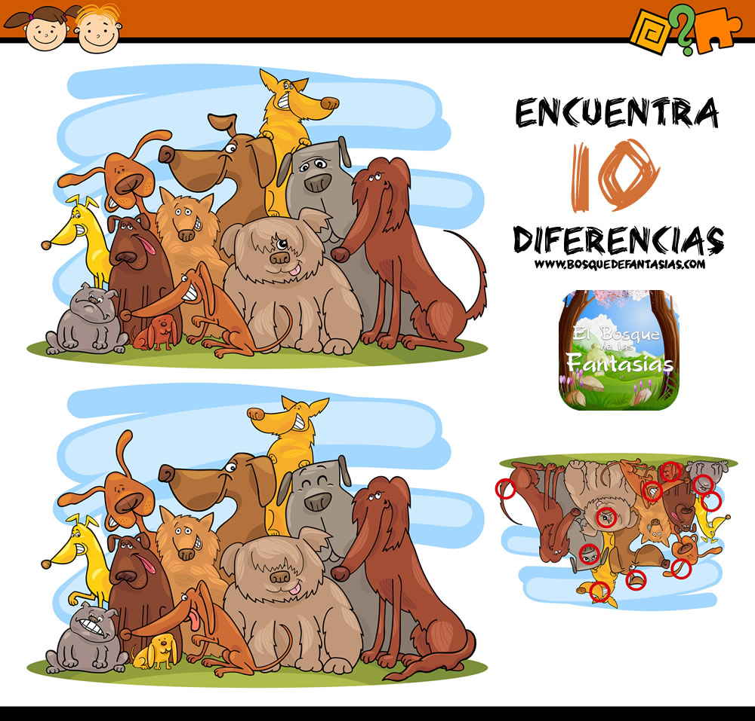

Encuentra las 15 diferencias.

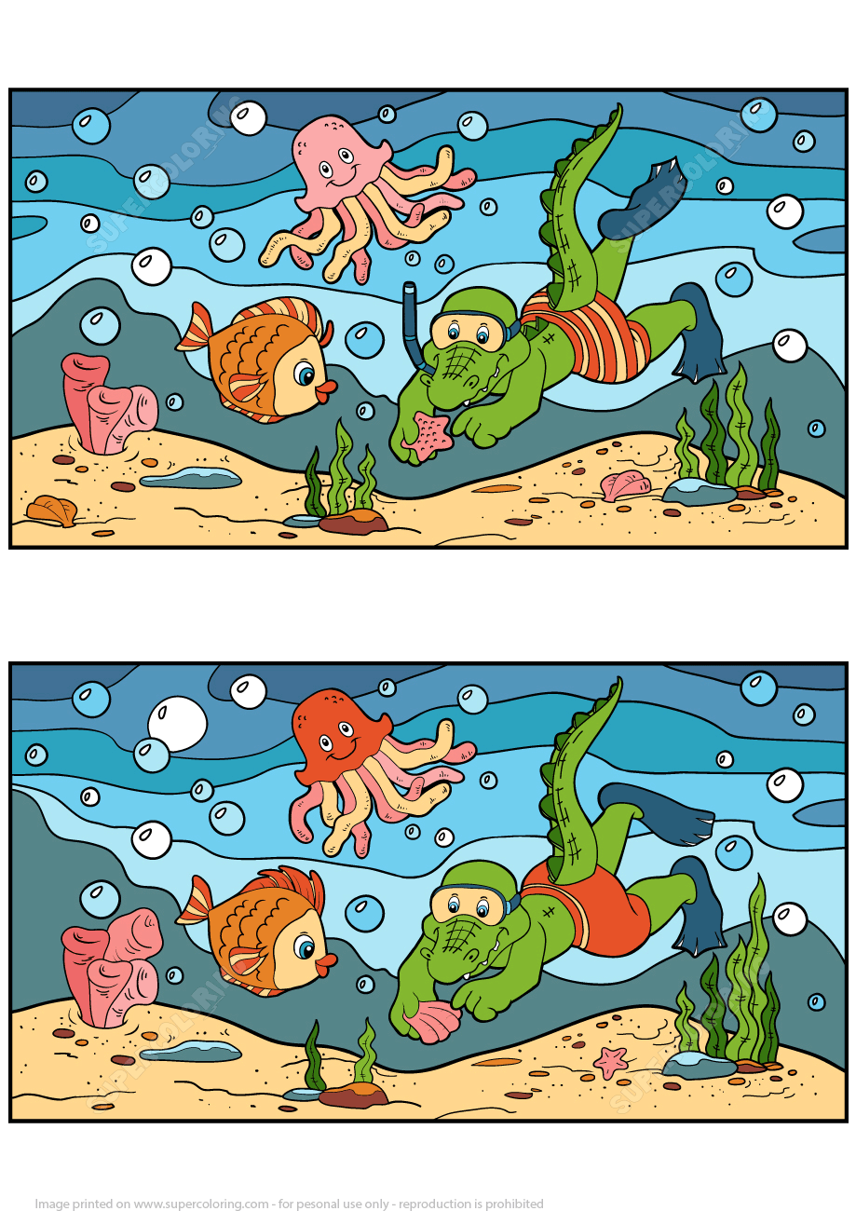

**¡Focaliza tu atención y colorea!**

1. Observa detalladamente la figura NÚMERO 1 y colorea de igual forma la figura NÚMERO 2.

Figura N°1 Figura N°2

|  |  |  |  |  |  |
| --- | --- | --- | --- | --- | --- |
|  |  |  |  |  |  |
|  |  |  |  |  |  |
|  |  |  |  |  |  |
|  |  |  |  |  |  |
|  |  |  |  |  |  |
|  |  |  |  |  |  |
|  |  |  |  |  |  |

|  |  |  |  |  |  |
| --- | --- | --- | --- | --- | --- |
|  |  |  |  |  |  |
|  |  |  |  |  |  |
|  |  |  |  |  |  |
|  |  |  |  |  |  |
|  |  |  |  |  |  |
|  |  |  |  |  |  |
|  |  |  |  |  |  |

|  |  |  |  |  |  |
| --- | --- | --- | --- | --- | --- |
|  |  |  |  |  |  |
|  |  |  |  |  |  |
|  |  |  |  |  |  |
|  |  |  |  |  |  |
|  |  |  |  |  |  |
|  |  |  |  |  |  |
|  |  |  |  |  |  |

|  |  |  |  |  |  |
| --- | --- | --- | --- | --- | --- |
|  |  |  |  |  |  |
|  |  |  |  |  |  |
|  |  |  |  |  |  |
|  |  |  |  |  |  |
|  |  |  |  |  |  |
|  |  |  |  |  |  |
|  |  |  |  |  |  |

|  |  |  |  |  |  |  |  |  |  |  |  |  |  |
| --- | --- | --- | --- | --- | --- | --- | --- | --- | --- | --- | --- | --- | --- |
|  |  |  |  |  |  |  |  |  |  |  |  |  |  |
|  |  |  |  |  |  |  |  |  |  |  |  |  |  |
|  |  |  |  |  |  |  |  |  |  |  |  |  |  |
|  |  |  |  |  |  |  |  |  |  |  |  |  |  |
|  |  |  |  |  |  |  |  |  |  |  |  |  |  |
|  |  |  |  |  |  |  |  |  |  |  |  |  |  |
|  |  |  |  |  |  |  |  |  |  |  |  |  |  |

|  |  |  |  |  |  |  |  |  |  |  |  |  |  |
| --- | --- | --- | --- | --- | --- | --- | --- | --- | --- | --- | --- | --- | --- |
|  |  |  |  |  |  |  |  |  |  |  |  |  |  |
|  |  |  |  |  |  |  |  |  |  |  |  |  |  |
|  |  |  |  |  |  |  |  |  |  |  |  |  |  |
|  |  |  |  |  |  |  |  |  |  |  |  |  |  |
|  |  |  |  |  |  |  |  |  |  |  |  |  |  |
|  |  |  |  |  |  |  |  |  |  |  |  |  |  |
|  |  |  |  |  |  |  |  |  |  |  |  |  |  |

1. Colorea los números con los siguientes colores.

 5 1

7 2

|  |  |  |  |  |
| --- | --- | --- | --- | --- |
| **1** | **9** | **3** | **4** | **1** |
| **2** | **6** | **6** | **7** | **2** |
| **3** | **5** | **2** | **1** | **7** |
| **5** | **4** | **1** | **2** | **4** |
| **8** | **7** | **6** | **9** | **8** |